Questions about the Tiger Flathead Dataset

Hello,

Some question came out from the dataset preliminary analysis.

**tiger flathead data_major zones.csv**

1. Is it possible to assume that the otolith radius at a certain age is the sum of all the previous otolith increments?
2. Why does the same fish change sex several times?
3. I have noticed that "YearCap" have been copied into "Year" correspondant to Age 1 in each fish. The true year correspondant to Age 1 should be the previous of Age 2 (e.g. Age2 = 2002 => Age 1 = 2001). But in this way the Year relative to Age 1 would be equal to "YearClass" (shouldn't it be greater by 1?).

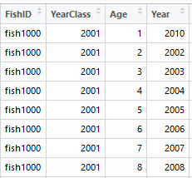

For exemple in fish1000 YearCap=2010, year relative to age 1 would be 2001, equal to Yearclass. Is it correct? Or should I consider Year(Age1) = 2002, Year(Age2) = 2003..... Year(Age8) = 2009?

In the second case sometimes YearCap=Year(MaxAge), as in fish2075.

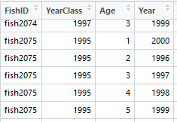

**environmental data.csv**

1. Data referred to totalcatch in Newcastle region are expressed in kg? In this case totalcatch would be smaller than CPUE.
2. In every year if CPUE is present, it is present totalcatch as well, except for 1984-Newcastle and 2011 Newcastle. Is it possible that totalcatch column is offset by one row in Newcastle?
3. Correlation between CPUE and totalcatch is low in all the regions but one. This is likely according to big variations in fishing effort through years, can you confirm that?

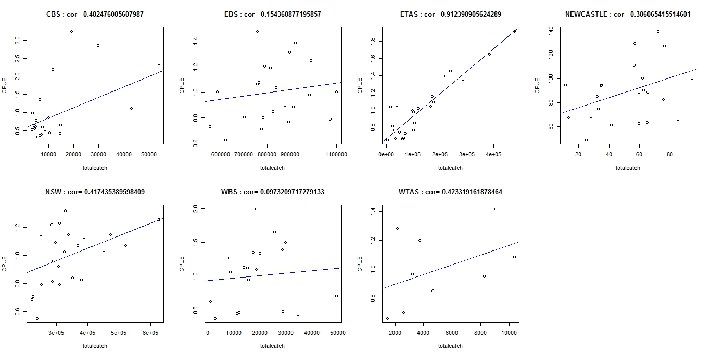

Thank you for the help.

Federico